Introduction
This document describes the adjustments that need to be made in order for the Postman tests to be able to run for Welcome Pickups staging environment appropriately and with valid data.

Postman tests on staging without any test adjustments

Only with having set the following environment variables:

URL: https://api.stgazure.welcomd.com/v1/emerging-travel
start_point: {"type":"iata","iata":"ATH"}
end_point: {"type":"coordinates","coordinates":{"lat":37.964228,"lon":23.725746},"address":"Welcome Pickups"}

We have the following test results:
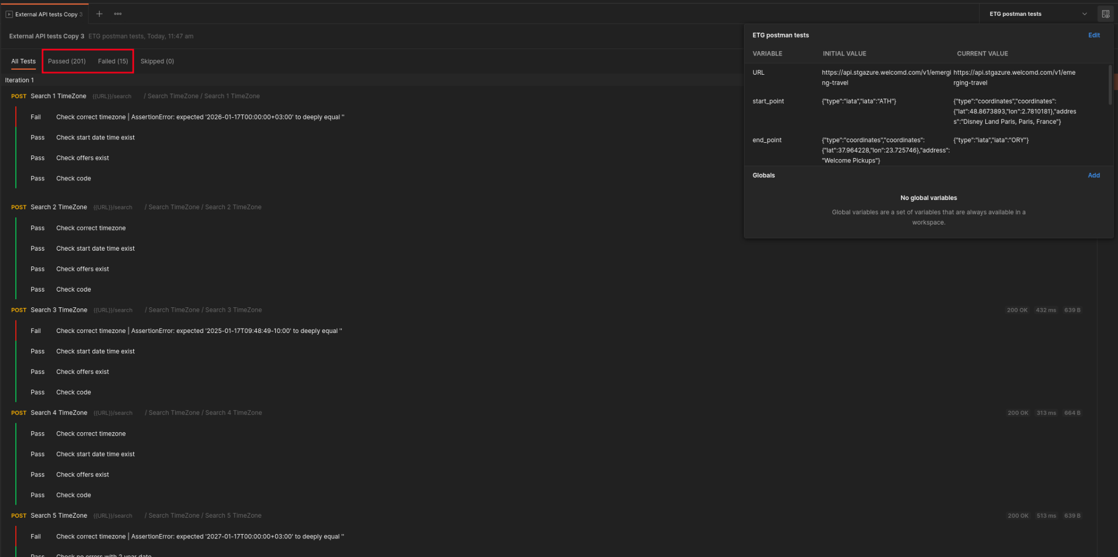
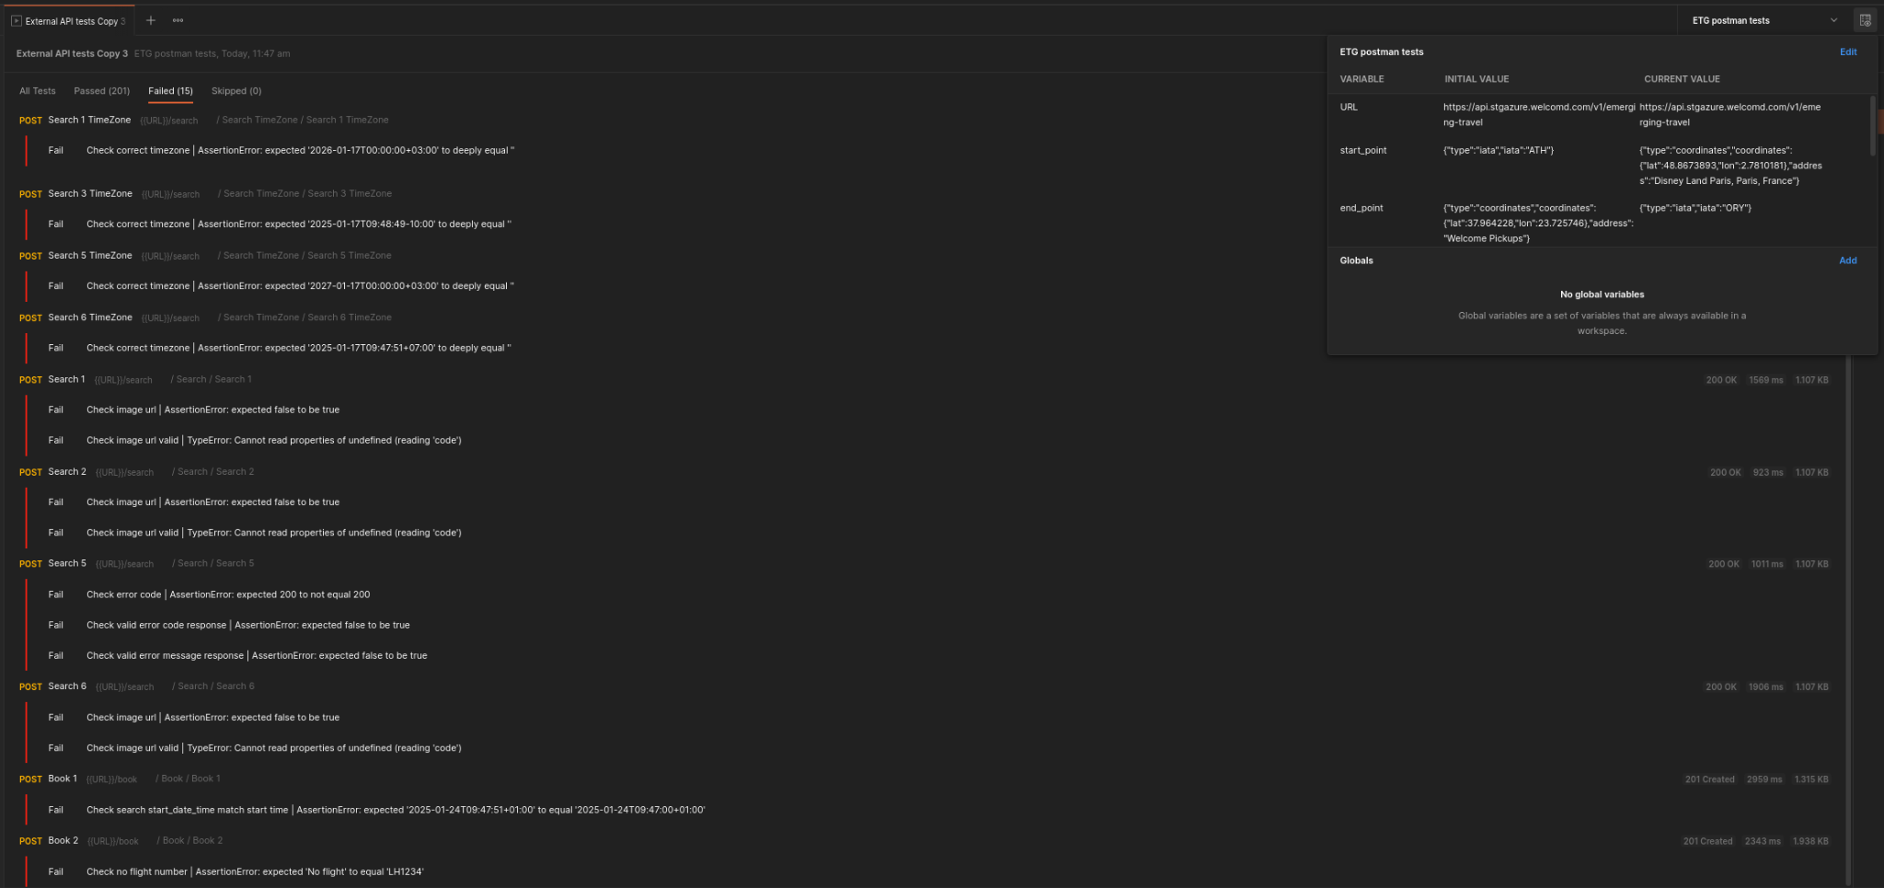

201 passed, 15 failed

Postman tests on staging with fixing the TimeZone related tests
Now the reason why TimeZone related tests fail is because on our staging environment we do not support the zones expected in the postman tests. Therefore if we:

- Adjust the start point and end point to be Athens locations for the “Search 1,2,3,5,6 TimeZone” tests to "start_point": {{start_point}}, "end_point": {{end_point}} , using thus the environment variable that we set in the beginning
- Adjust the start point and end point for the “Search 4 TimeZone” test to "start_point": {"type":"iata","iata":"BCN"}, "end_point": {"type":"iata","iata":"GRO"}
- Adjust the expected test timezones of the “Search 1,2,3,5,6 TimeZone” tests to "+02:00" (Athens zone)
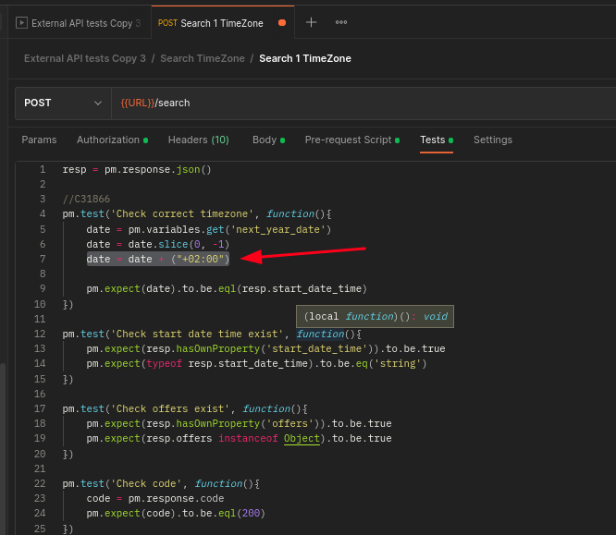
- Adjust the expected test timezones of the “Search 4 TimeZone” tests to "+01:00" (Barcelona zone)
- Make sure our environment start and endpoint still have the values of start_point: {"type":"iata","iata":"ATH"}, end_point: {"type":"coordinates","coordinates":{"lat":37.964228,"lon":23.725746},"address":"Welcome Pickups"} in both Initial value and current value (Because some tests change these environment variables)

And run the tests, we get:

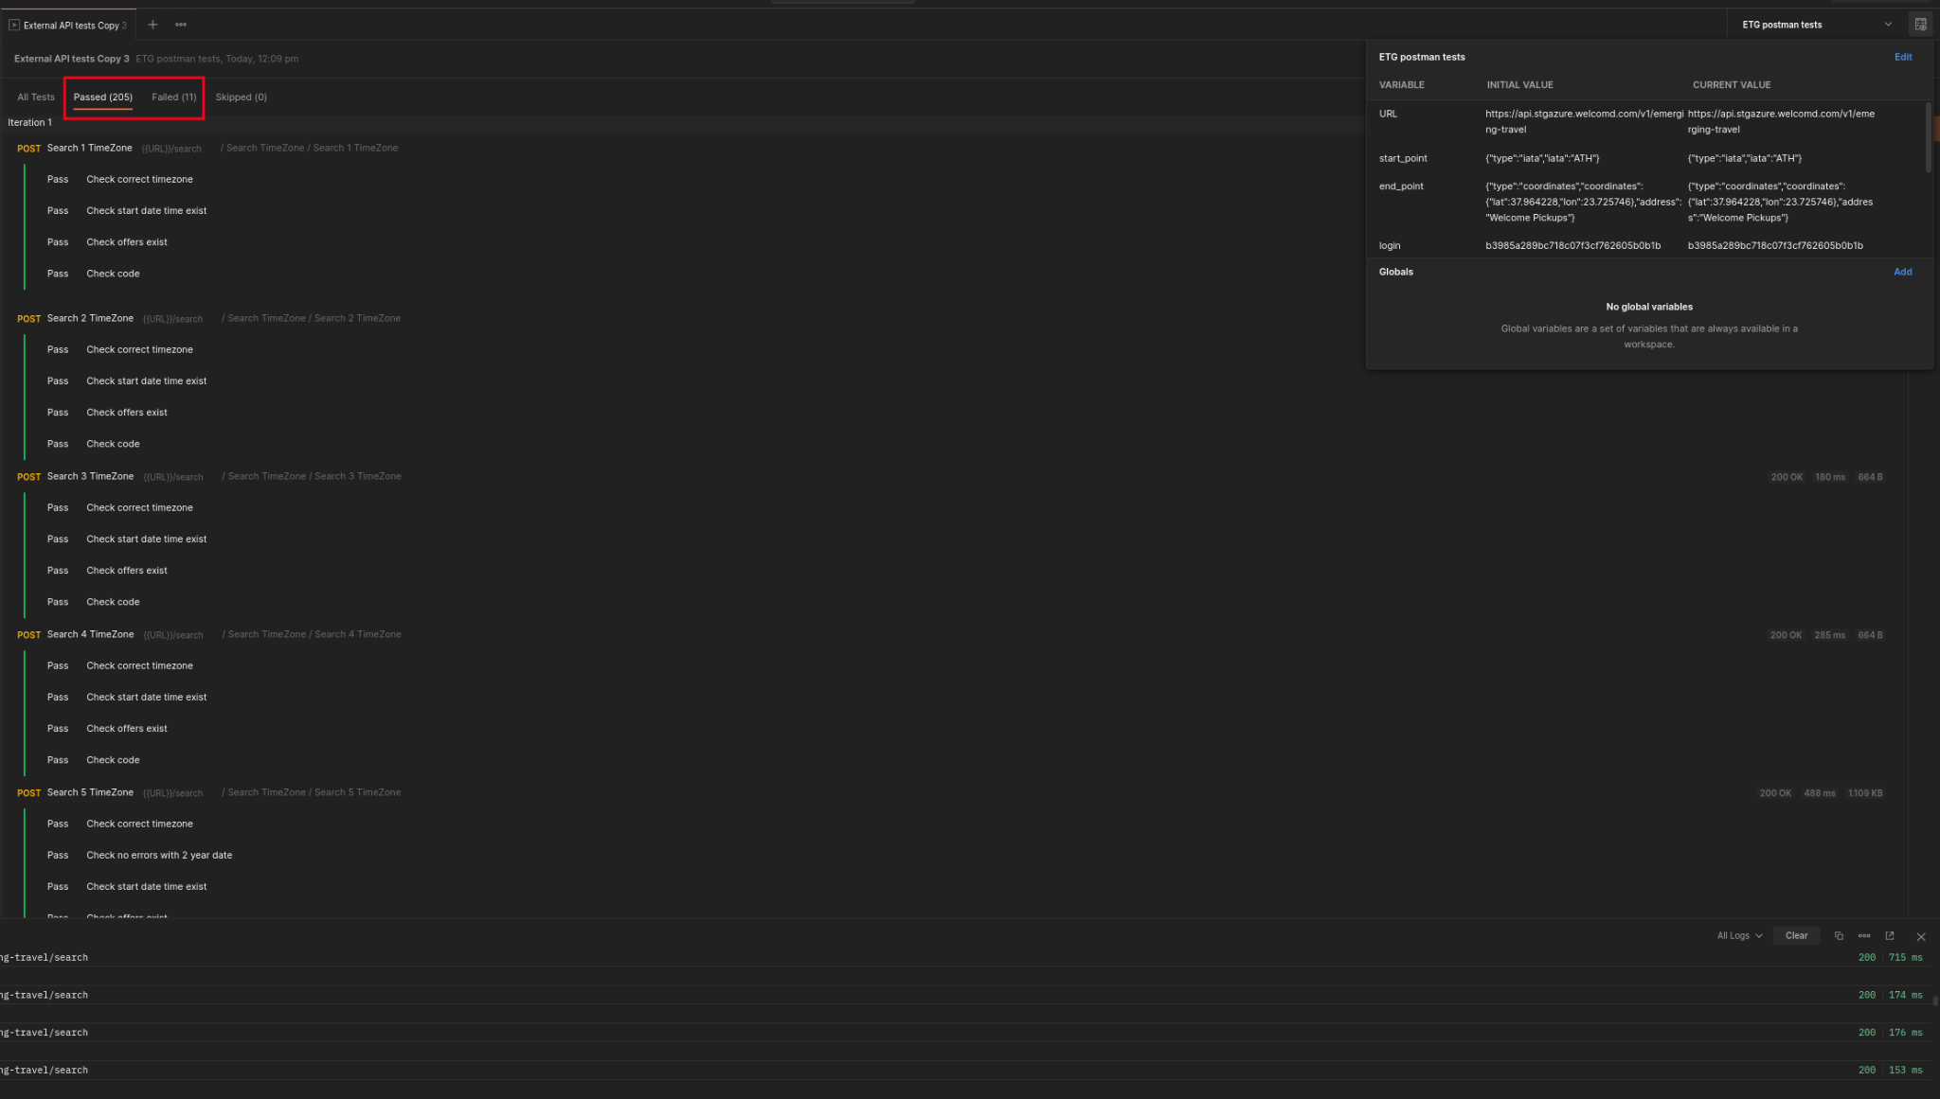
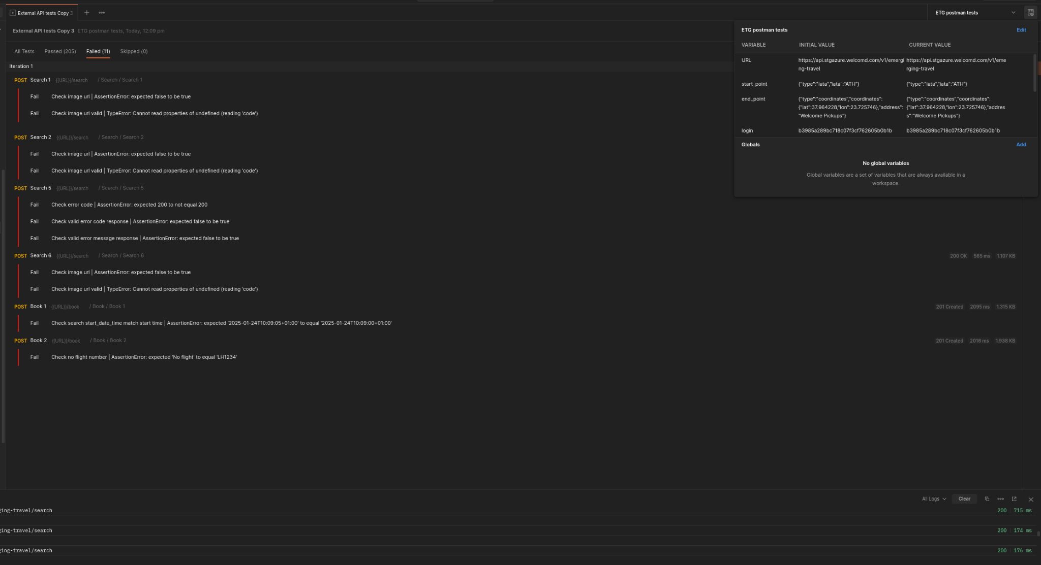

205 passed, 11 failed

We fixed the Search TimeZone related tests.

Postman tests on staging with fixing/deprecating the image url related tests

Now in the ETG api documentation https://openapi.emergingtravel.com/?urls.primaryName=ETG%20Transfers%20API%20v1#/default/post-search
We cannot seem to find any references to the field image_url in /search response.
So the only logical thing to do here with these tests is to mute / comment them out.

We do that for Search 1,2,6
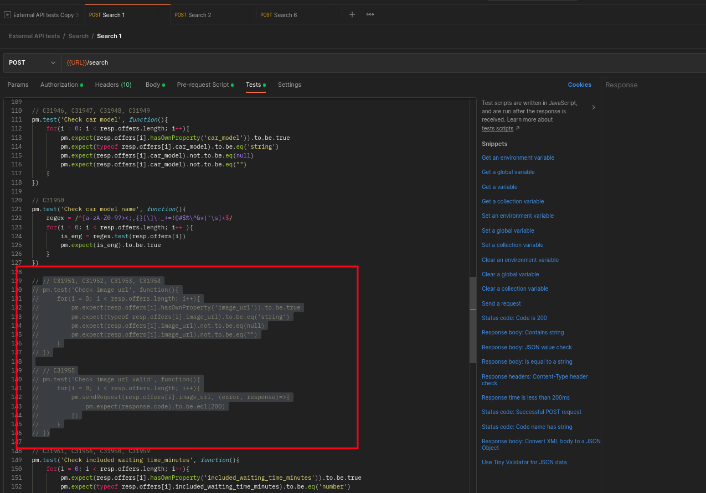

And in Search 1 adjust the Pre-request Script
start_point = {"type":"iata","iata":"ATH"}
end_point = {"type":"coordinates","coordinates":{"lat":37.964228,"lon":23.725746},"address":"Welcome Pickups"}
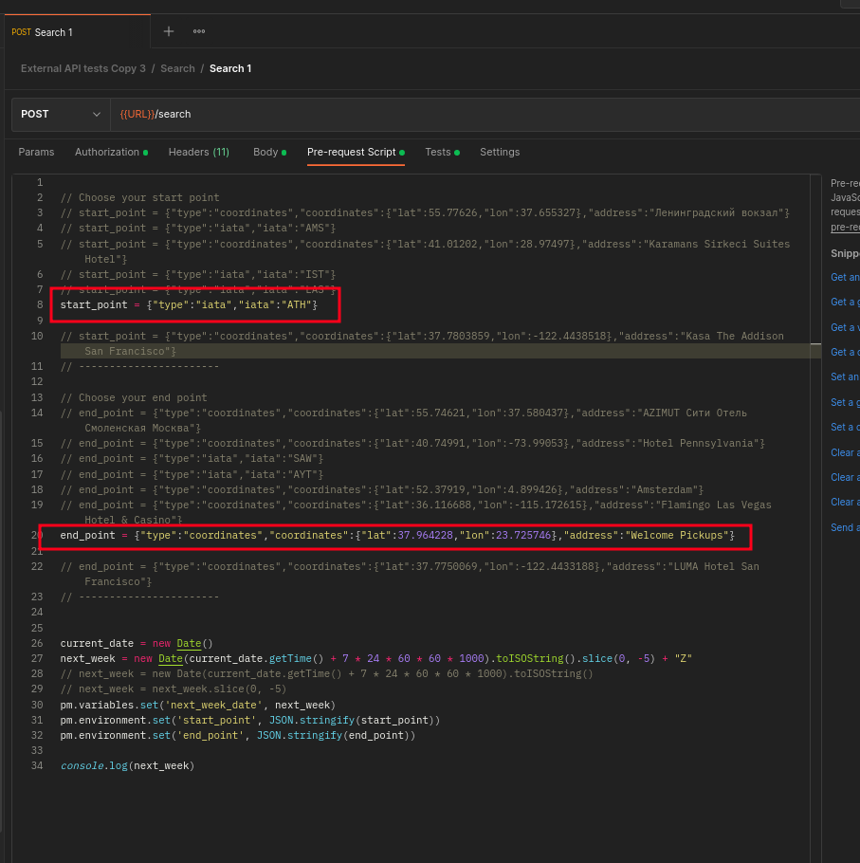

And run the tests, we get:
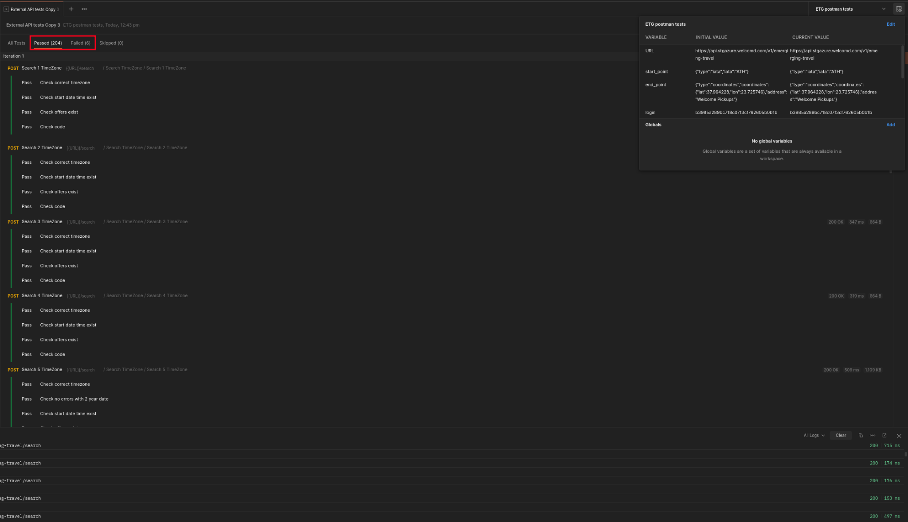
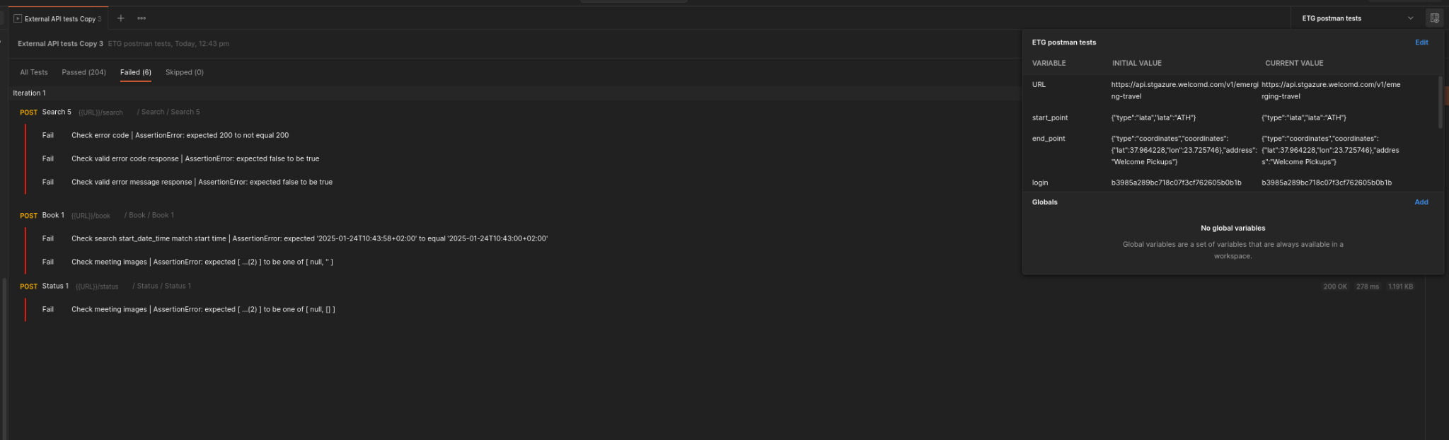

204 passed, 6 failed

Postman tests on staging with fixing the meeting images related tests

Regarding the error for the meeting images in the “Book 1” tests, our current staging fixtures return meeting images for the Airport of Athens, therefore we temporarily removed the meeting images of that location.

Regarding the error for the meeting images in the “Search 1” tests, it seems that there might be a logical error in the test itself.
// C49827
pm.test('Check meeting images', function(){
if(resp.hasOwnProperty('meeting_info')){
if(resp.meeting_info.hasOwnProperty('images')){
if(Array.isArray(resp.meeting_info.images) && resp.meeting_info.images.length < 0){
for(i = 0; i < resp.meeting_info.length; i++){
pm.expect(resp.meeting_info.meeting_info.images[i]).to.be.eq('string')
}
} else {
pm.expect(resp.meeting_info.images).to.be.oneOf([null, []])
}
}
}
})

Here we have
resp.meeting_info.images.length < 0

Which means if there are no images then check if the images exist and are of type string.
While it probably should be if there are images then check if the images exist and are of type string.

And therefore reverse the < like so:
resp.meeting_info.images.length > 0

We should also adjust the check from
pm.expect(resp.meeting_info.images).to.be.oneOf([null, []])
To
pm.expect(resp.meeting_info.images).to.deep.equal([]);
Or null
In order to be a valid javascript check

If we now run the tests, we get:
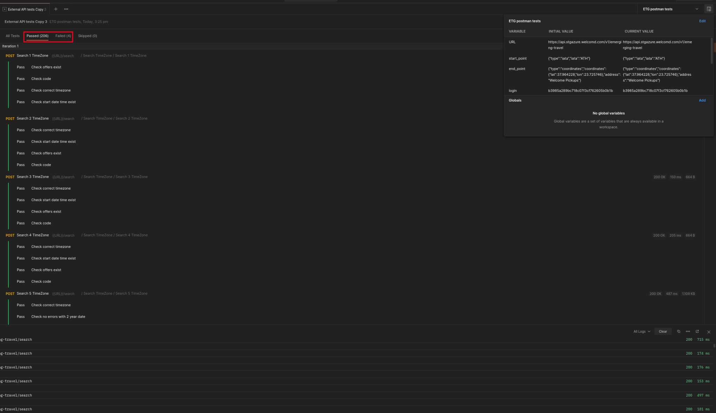
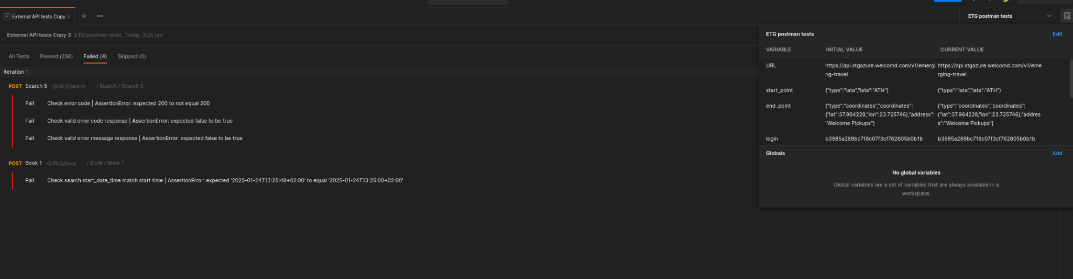

206 passed, 4 failed

Postman tests on staging with fixing the Search 5 tests

Here it seems that we had a bug where we were returning a quote even though the passenger field was null. This issue is now fixed.

If we now run the tests, we get:
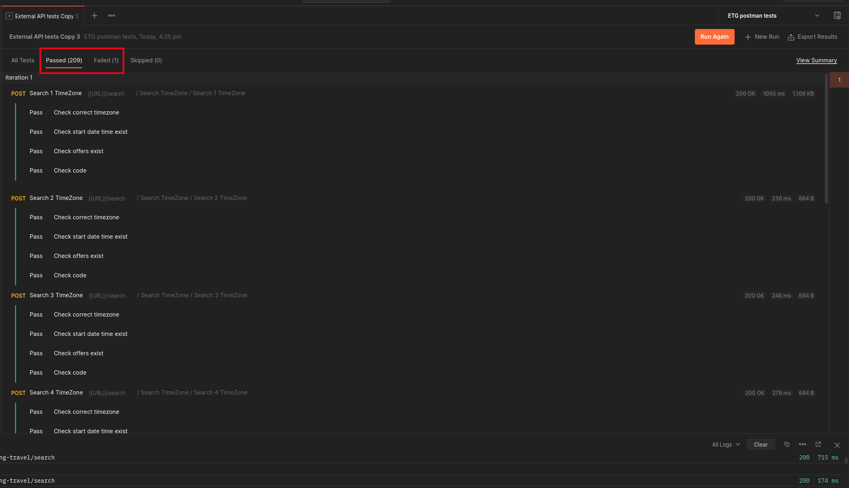

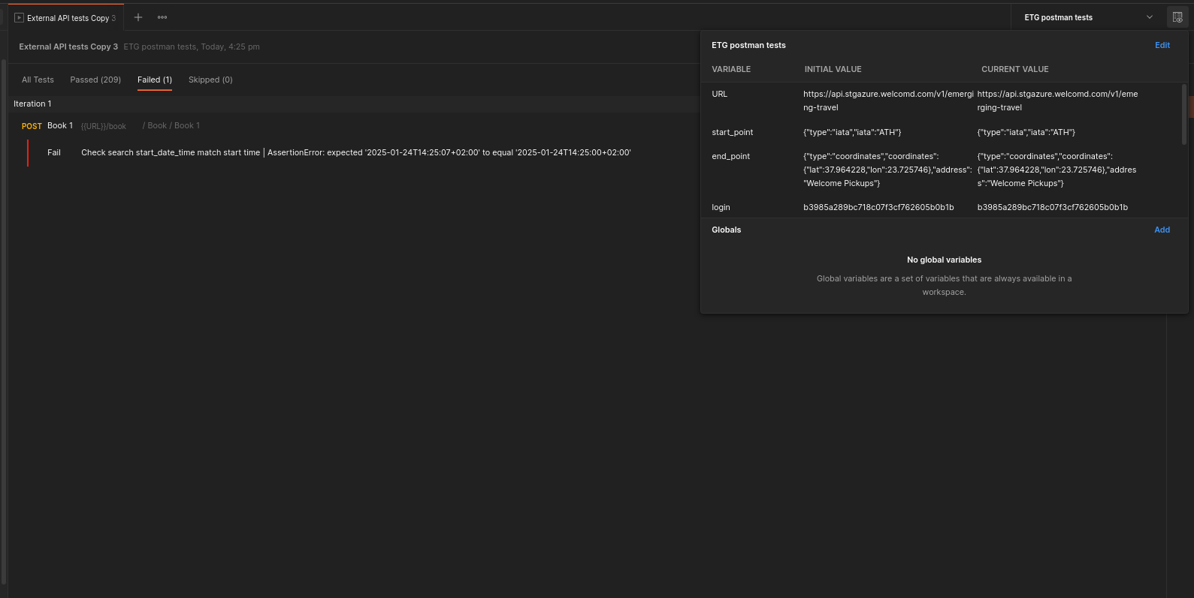

209 passed, 1 failed

The reason why the last test fails is because the request of the /search we sent a date time up until the character that represents the seconds. In our system we store the transfer operation time up until the minute characters, so in the comparison between the two of those we have a difference in the seconds characters:


We can fix that by adjusting the test to check only up until the minute character:
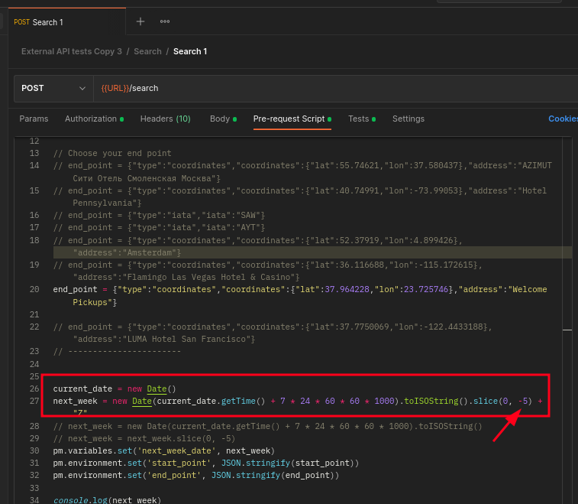

Changing:
next_week = new Date(current_date.getTime() + 7 * 24 * 60 * 60 * 1000).toISOString().slice(0, -5) + "Z"
To
next_week = new Date(current_date.getTime() + 7 * 24 * 60 * 60 * 1000).toISOString().slice(0, -8) + "Z"

And If we now run the tests, we get:

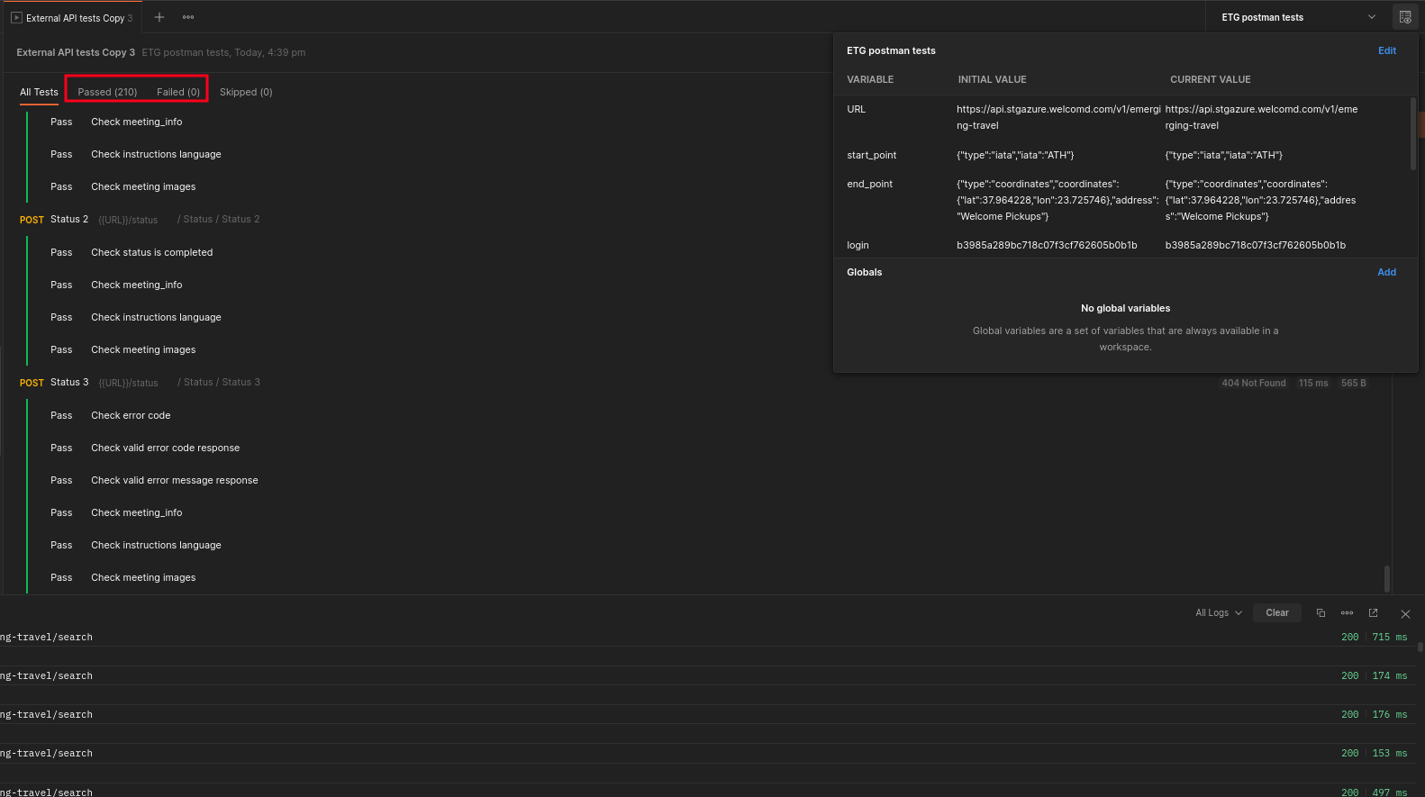

210 passed, 0 failed!

